**Student Name: Hamish Kirkman**

**Student ID: 99218512**

1. Table

   Description automatically generated
2. Table

   Description automatically generated with medium confidence
3.   
     
     
     
   Table

   Description automatically generated
4. 
5. Table

   Description automatically generated
6. Table

   Description automatically generated with medium confidence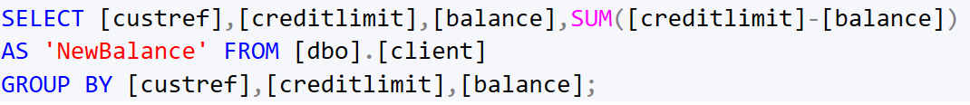
7. Table

   Description automatically generated with medium confidence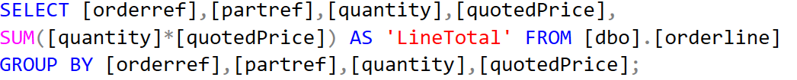
8. Table

   Description automatically generated
9. Table

   Description automatically generated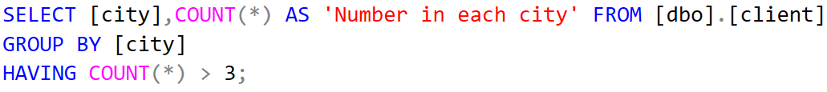
10.   
      
    Table

    Description automatically generated
11.   
    Table

    Description automatically generated
12. Text

    Description automatically generated with medium confidence  
    Table

    Description automatically generated
13. Table

    Description automatically generated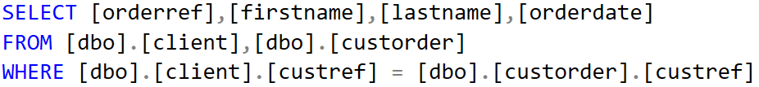
14. Table

    Description automatically generated with medium confidenceText

    Description automatically generated
15. Table

    Description automatically generatedText

    Description automatically generated
16. Table

    Description automatically generatedText

    Description automatically generated with medium confidence
17. Text

    Description automatically generated  
    Table

    Description automatically generated
18. Text

    Description automatically generatedTable

    Description automatically generatedText

    Description automatically generated
19. Table

    Description automatically generated
20. Table

    Description automatically generated  
    Graphical user interface, text, application

    Description automatically generated
21. Table

    Description automatically generated